**Leader Overview**

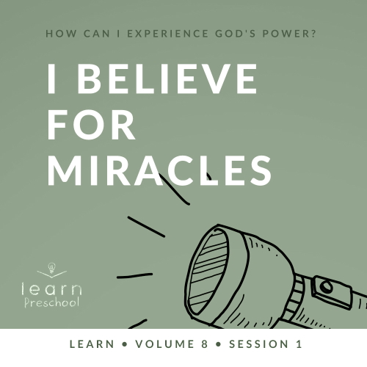

**Volume Overview**

**How can I experience God’s power?**

*When we think of power, we might think of physical strength or mental toughness. While God surely wants us to experience physical health and clarity of mind, He desires that we experience His supernatural power too.*

*In the Bible, it’s clear that our God—revealed through the Father, the Son and the Holy Spirit—is powerful. He spoke the world into existence and sustains the universe by the power of His Word (*[*Hebrews 1:3*](https://ref.ly/logosref/Bible.Heb1.3)*). God displayed His power in many ways in the Old Testament for His people. In the New Testament, Jesus’ life and works revealed His power over sickness, spiritual forces, and even the grave. After Jesus’ resurrection, God sent the Holy Spirit so we could have the power to do kingdom work today (*[*Acts 1:8*](https://ref.ly/logosref/Bible.Ac1.8)*). Clearly, God is powerful! But how do you and I experience His power? That’s the question we’ll explore in this volume.*

**Session Overview**

**I Believe for Miracles**

*In this* **Learn** *session, preschoolers will discover God performed miracles to take care of Elijah’s need for food and water during a drought. We follow a God who not only sees what we need but also acts with supernatural power to help us. God provided for Elijah, and we can trust God to provide for us.*

**Bible Lesson**

Elijah and the Ravens

[1 Kings 17:1–6](https://ref.ly/logosref/Bible.1Ki17.1-6)

**Faith Fact**

I believe God can do miracles.

**Faith Verse**

[John 14:12](https://ref.ly/logosref/Bible.Jn14.12) (NLT)

“I tell you the truth, anyone who believes in me will do the same works I have done.”

**Preparing for the Session**

**Leader Preparation Time: 20–25 Minutes**

|  |
| --- |
| ***You Will Need***  ***Preservice Activities***  *• Toy or real piece of bread*  *• Scissors*  *•* ***Preservice Bible Story Warm-Up Page****, one per every ten kids*  *• Mini sandwiches or crackers*  ***Large Group***  *• Bible*  *• Worship songs (Song suggestions: “My God Is So Big” by Hosanna Kids; “What a Mighty God We Serve” by Christian Songs for Kids; “Love the Lord” by CJ and Friends)*  *• For groups not using a phone or tablet only, add:*  *• Projector or TV*  *• Laptop*  *•* ***Faith Fact Sound video*** *(bell ringing)*  *•* ***Faith Fact Slide***  *•* ***Faith Verse Slide***  *•* ***Bible Lesson Video A***  *•* ***Bible Lesson Video B***  ***Small Group***  *•* ***Small Group Activity Page****, one per kid*  *• Crayons*  *• Bag of round soup crackers (oyster crackers)*  *• One or two dolls or puppets*  *• One or two bowls*  *• Beans or seeds, one or more per kid*  *• Potting soil or container of dirt*  *• Small paper cups, two per kid*  *• Water*  *• Permanent marker*  To access session content and videos from a computer, visit: [BibleEngagementProject.com/downloads](https://bibleengagementproject.com/downloads) |
| ***Getting Ready***  ***Preservice Activities***  *• Set out toys and snacks.*  *• Print and cut apart the* ***Preservice Bible Story Warm-Up Page****, one per every ten kids.*  *• Hide the pictures in the playing area.*  ***Large Group***  *• Download videos and slides if needed.*  *• Select worship song(s) and have them ready to play.*  ***Small Group***  *• Print copies of the* ***Small Group Activity Page****, one per kid.*  *• Fill cups with dirt, one per kid.*  *• Write kids’ names on the cups with the permanent marker.*  *• Fill small cups with enough water to water one seed, one per kid.*  ***First time leading* Learn *for Preschool? Check out the*** [**Facilitator Guide**](https://0b769b0ed3569ef9d18b-f88d8272f61086866d50d048b43ef630.ssl.cf2.rackcdn.com/sites/biblengagementproject/Listen_Facilitator_Guide.pdf)**.** |

**Preservice Activities**

*See what’s needed at the beginning of the session.*

**Bible Story Warm-Up**

Our bodies need us to do certain things to stay healthy. How do we keep our bodies healthy? *(Allow responses.)* You all know great ways to take care of your body. I want to show you something. Tell me what you think of when you see it. *(Allow responses.)*

• *Pass around a real or toy piece of bread.*

Our bodies need food so we can grow. Where does food come from? *(Allow responses.)* Fruits and vegetables grow in the ground or on trees or bushes. Farmers collect the food and deliver it to grocery stores for people to buy. Does anyone here want to pretend to be a farmer? *(Group response)* Great! Let’s all pretend to put on some farming clothes that can get dirty while we’re farming.

• *Demonstrate pretending to put on overalls/apron/hat.*

Now you’re ready. I’ve hidden pictures of food around the room. When I say, “Go,” you can collect one picture of food. How many pieces of food are you going to collect? *(Group response)* Go to work, farmers.

• *Allow kids to collect and talk about what they found until everyone has returned.*

• *If you have fewer kids, have them collect more than one food item. You could also print multiple copies of the* ***Preservice******Bible Story Warm-Up Page,*** *so the kids can collect more than one food item.*

You’re great farmers! You collected a lot of food so people can eat. Sometimes people get hungry, but they don’t have enough food in their cabinets and refrigerators.

• *Ask questions to introduce the Bible story and theme.*

What does your face look like when you’re very hungry and need to eat?

Do you think God sees when people don’t have enough food to eat?

How do you think God feels about people when they don’t have enough food?

Our Bible story today is going to show us how much God cares about someone’s need for food and what God did to help. Today, we’ll see other things you might need.

**Snack**

**Mini Sandwiches or Crackers**

*As kids are eating the snack, share the following:*

Today, we’ll explore a Bible story about how God gave bread and meat to a man who really needed it. If you were going to deliver food to someone who needed it, how would you get it to them? *(Allow responses.)* What kind of food would you send to someone who’s hungry? *(Allow responses.)* Those are some great ideas. We’ll find out what God did in our Bible story. *(Whisper it like a secret.)* The way God gave him the food was a miracle, which is something only God can do. I can’t wait until we find out more about this from Lizzy.

**Free Play**

*Any extra time can be spent playing with toys.*

**Transition**

*A few minutes before service begins, have kids make their way to the large group area and sit in their designated areas.*

**Large Group**

**25 Minutes**

*See what’s needed at the beginning of the session.*

**Introduction**

We get to come to church and learn more about God and how much He loves you and me. *(Hold up the Bible.)* Point to yourself and say, “God loves me.” *(Group response)* Now, point to a friend and say, “God loves you.” *(Group response)*

Today, we’ll learn about a man named Elijah. Let’s talk about one of the differences between us and Elijah. Elijah lived in Bible times. That means he didn’t have a refrigerator in his house or a faucet with cold water. He also didn’t have a grocery store like we have today where we can go to and buy food. However, Elijah was like us in two important ways. Everybody, hold up one finger. *(Group response)* First, God spoke to Elijah, and God wants to speak to us. Everybody, hold up two fingers with me. *(Group response)* Second, God did a miracle for Elijah, and God can do a miracle for us.

**Faith Fact**

In fact, that’s the amazing truth in our Faith Fact today. **I believe God can do miracles.**

• *Show the* ***Faith Fact Slide.***



Say it with me. **I believe God can do miracles.** Now, I’m going to give you a clue about our Bible story with Elijah. It involves a creature that flies in the air and says, “Caw, caw.” Can you guess what creature it is? *(Group response)*

Yes! It’s a bird! Let’s warm up our wings. *(Demonstrate flapping arms like wings.)* Let’s say our Faith Fact while we pretend to fly like birds. **I believe God can do miracles.** Now, let’s use our wings to fly in a little circle in our spots. *(Group response)* Say the Faith Fact one more time. **I believe God can do miracles.**

**Bible Time**

My wings are a little tired. How about yours? *(Group response)* Let’s sit down and rest while we visit our friend Lizzy. I love hearing Lizzy tell us what she is learning from the Bible. Let’s see what she has for us today.

• *Play* ***Bible Lesson Video A****.*

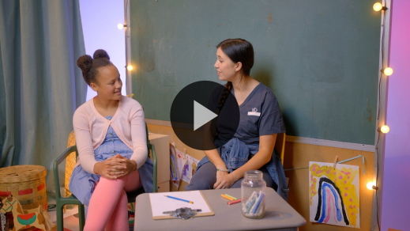

Wow! God does miracles just like our Faith Fact tells us. Sometimes, He also asks people like us to be a part of the miracles. That’s what our Faith Verse says. You’re doing a great job learning our new Faith Verse.

**Worship**

God is so big and He can do anything. He created our bodies to need food. He created plants to grow in the ground to make food for us. God is so wonderful that He even sees the very smallest needs and worries that we have. Let’s take a few minutes to praise God for how big He is. Let’s worship Him for how wonderful He is to love us.

**Praise**

Are you glad God sees everything you need today? Spin around in your spot. *(Group response)*

Do you believe God can do miracles? Give me two thumbs up. *(Group response)*

Who wants to tell God thank You? Reach your hands up to the sky. *(Group response)*

**Sing**

One way we worship God is by singing. I’m not the only one who can hear your voice when you sing and worship. God hears you, and He sees your heart wanting to praise Him.

• *Lead the kids in singing one or two songs. See song suggestions at the beginning of the session.*

**Prayer**

God heard your voices singing. Now, let’s let talk to Him in prayer. Everyone, show me your wiggling fingers. *(Group response)* Wiggle, wiggle, wiggle them some more. Now, put your hands together and fold your fingers as we get our hands and our hearts ready to pray.

|  |
| --- |
| God, thank You for loving us and for the miracles You do for us every day. I pray for anyone in this room who needs a special miracle today. I pray for anyone who needs more food to eat. I pray for moms, dads, or family members who need to turn their heart to You. We ask that You do a miracle for them like You did for Elijah. Amen. |

**Bible Time cont’d**

Hmm, speaking of Elijah, I wonder what else Lizzy has been up to. Do you think she’s ready to tell us the Bible story? *(Group response)* Maybe Grandpa will tell us the Bible story this time. Let’s check in with Lizzy now.

• *Play* ***Bible Lesson Video B.***

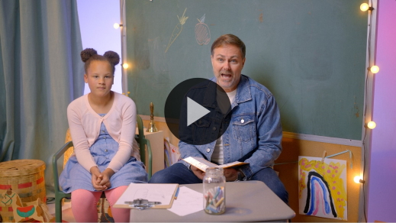

Wow! I wonder what it would be like to have a bird deliver food to us. God thinks in ways that are amazing to me. I love that He sometimes answers prayers in the ways we ask, but many times He answers prayers in ways we could never imagine. I believe God can do miracles for us just like He did for Elijah. Do you believe that? *(Group response)*

Let’s see what we can remember from our Bible story. I’m going to act out clues, and you yell out what you think is happening.

* *Act hungry and thirsty with your hand on your stomach and your mouth open.*

Elijah was very hungry and thirsty, wasn’t he? God saw that he didn’t have enough food to eat.

* *Sit down. Put your hands over your eyes like you’re looking in the distance. Then, look surprised. If the kids haven’t guessed yet, flap your arms like a bird.*

Can you imagine if a bird brought food to your house today? That would be pretty crazy! Great job of guessing my clues. I hope that you always remember this Bible story and the lesson that God can do miracles for you.

**Response Time**

• *Play a worship song quietly.*

We’re going to take some time to respond to what we’ve learned today. Hold out your hands like someone is giving you a treat. You’re going to ask God for whatever you need today. Think for a moment if there’s a miracle you need. Maybe you or someone you care about is sick. Maybe you’re feeling sad because something is really bothering you. Maybe you and your family need food like Elijah did.

If there isn’t something you need right now, think about the good miracles God has done for you in the past. You can thank Him that He created fruits, vegetables, trees, sunshine, and grass for us to enjoy. You can thank Him for how much He loves you.

• *Pause for silent response.*

Let’s pray.

• *Optional: Have the kids repeat phrases of the prayer after you.*

|  |
| --- |
| Dear God, thank You for all that You’ve done for us and the miracles You will do for us. We praise You because You do miracles. Amen. |

**Faith Verse**

One of the ways we remember what God has done for us is by learning verses from the Bible. Let’s say our Faith Verse and do the actions together.

[John 14:12](https://ref.ly/logosref/Bible.Jn14.12) (NLT)

“I tell you the truth, anyone who believes in me will do the same works I have done.”

**John** *(hands at waist, spread apart, palms up and out)*

**14:** *(hands together like a clap)*

**12** *(hands opened to “book”)*

**“I tell you the truth,** *(both open hands to mouth)*

**anyone who believes in me** *(raise both hands)*

**will do the same works** *(slap hands together 3x)*

**I** *(index fingers pointing up)*

**have done.”** *(arms folded across chest)*

• *Show the* ***Faith Verse Slide****.*

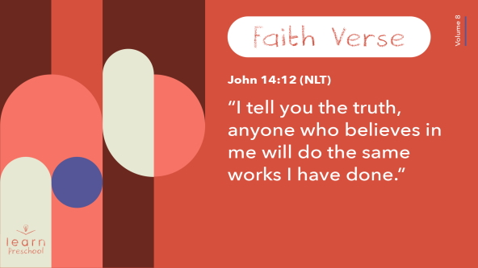

That’s a big promise. God can do big things, and our Faith Verse says He will help us to do big things. I love learning God’s Word with all of you.

**Closing**

Did you learn more about God today? *(Group response)* Let’s see if we’ve done everything. Clap one time for each thing I list. We’ve worshipped God by singing and praying. *(Group response)* We’ve learned a great Faith Verse from the Bible. *(Group response)* We’ve discovered a fun Bible story when God used birds to deliver food to Elijah. *(Group response)* We know God can do miracles. *(Group response)*

• *Play the* ***Faith Fact Sound*** *video (bell ringing).*

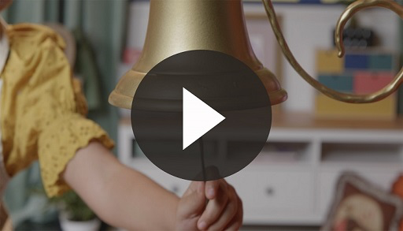

That reminds me of our Faith Fact. Let’s practice our Faith Fact one more time. **I believe God can do miracles.**

• *Show the* ***Faith Fact Slide.***



Let’s flap our arms like we’re birds delivering food while we say our Faith Fact as loudly as we can. **I believe God can do miracles.**

**Dismissal to Small Groups**

Great job! Now, you’re going to spend more time with your friends doing some fun activities in your small groups.

• *Dismiss the kids by groups*.

|  |
| --- |
| ***Leader Tip:*** *This can be done by assigning color teams or by age groups. Note that some young preschoolers may not know their age. Using a colored sticker, jersey, or wristband will help separate the kids and help identify their small groups.* |

**Small Group**

**25 Minutes**

*See supplies and prep instructions at beginning of session or in each activity below.*

|  |
| --- |
| ***Leader Tip:*** *Small groups can alternate to each circle, or all groups can do each activity at the same time. If you choose to alternate, you will need at least one leader per circle.* |

**Circle 1**

**Group Connection**

**Growing Like Seeds**

In our Bible story today, we heard about how the plants stopped growing because they didn’t get enough water. That’s why there wasn’t enough food for Elijah and the people around him. Plants need water and light to grow. What’s the name for the light in the sky during the day? *(Group response)*

Let’s pretend to be seeds that want to grow into plants. I’m going to show you where I want you to be planted while you think about what kind of plant you want to be.

• *Separate kids far enough from each other so they have space to stand up and spread out their arms.*

You could be an apple tree or a blueberry bush. You could grow bananas or avocados. What kind of plant are you? *(Allow responses.)* First, let’s start as tiny little seeds all covered up deep in the dirt.

• *Demonstrate squatting on the ground and curling your arms in closely.*

Now, we need some water. Hold out your hands to catch water and take a little sip. That water helps us grow a little bit.

• *Go from squatting to bending at waist*.

What else do we need? (*Group response)* Let’s turn our face to the sun and gather that sunlight. Ahh, that sunshine helps us poke our head out of the dirt. Then, we’ll start to grow quickly.

• *Stand up quickly.*

Doesn’t that feel good? Look around. This is your first chance to see where you’re planted. What are some things you want to pretend to see around you? *(Allow responses.)*

Here’s some rainwater falling from the clouds. Let’s drink up a lot of it.

• *Cup hands and pretend to drink.*

Now, we have some branches ready to pop out.

• *Demonstrate putting out arms with hands in fists.*

Now, we’re ready to grow some fruit.

• *Spread out each finger.*

Let’s count our fruit 1, 2, 3, 4, 5, 6, 7, 8, 9, and 10. You’ve all grown such beautiful fruit. Isn’t it amazing that the fruit, vegetables, and grains we eat start out as a seed and grow into plants? *(Group response)*

**Circle 2**

**Activity Page Time**

**How Many?**

|  |
| --- |
| ***You Will Need***  *•* ***Small Group Activity Page****, one per kid*  *• Crayons*  ***Getting Ready***  *• Print copies of the* ***Small Group Activity Page****, one per kid.* |

The Activity Page reminds us of some of the things we heard about in our Bible story. On the left side we see a man sitting down. Who do you think that might be? *(Allow responses.)* Do you think Elijah looks hungry? *(Group response)* What other things do you see on the page?

• *Help kids think about where the items occurred in the Bible story.*

• *Give each kid a copy of the* ***Small Group Activity Page*** *and crayons.*

You all remember the things from this story so well! Let’s say the numbers we see on the page. *(Group response)* You got it! Now, count how many things are in each box and draw a line to that number.

Let’s do the first one together. How many men are sitting in the picture? *(Group response)* One, so we find the number 1 on the page and draw a line to it. Great job! Now, match the rest of the pictures to the numbers that show how many things there are in each box.

• *Give kids time to finish their pages. Help them with the counting, if needed.*

• *During the activity, interrupt and practice the Faith Fact:* **I believe God can do miracles.**

• *Play the* ***Faith Fact Sound*** *video. Review the Faith Fact even if you can’t play the sound.*



**Circle 3**

**Feet-to-Floor Game Time**

**Raven Dash**

|  |
| --- |
| ***You Will Need***  *• Bag of round soup crackers (oyster crackers)*  *• One or two dolls or puppets*  *• One or two bowls*  *No prep needed for this activity.* |

For this game, you’ll need your running feet and some flying wings. I know you can run really fast, so I think you’re going to like this game. We have a doll that we’ll pretend is Elijah. And look, I think he’s very hungry. Can you see it on his face? *(Group response)* Let’s follow our Bible story example. We’ll put our Elijah over here where God told him to go.

• *Set the doll and a bowl at the end of the relay area.*

• *Hold up the bag of crackers.*

• *If you have a large group, have two teams race at the same time and use two dolls and bowls.*

Here’s some food that we can give to Elijah. What animal delivered the food to Elijah? *(Group response)* Right! What do you think we should pretend to be as we deliver the food? *(Group response)* Yes! You’ll be the ravens. You’ll start here one at a time, and I’ll give you food for Elijah. Then, you’ll fly to Elijah and put the food in his bowl. Let’s see how quickly we can feed him. While you wait for your turn, watch for your friends to drop off the food so you can say, “Thank you,” for Elijah in any funny voice you can think of. Are your wings ready, ravens? *(Group response)* Okay, let’s go!

• *Allow every kid to get a turn.*

Wow, you can fly really fast! You delivered food to Elijah just like the ravens in our Bible story. God did a miracle for Elijah by sending ravens with food. That reminds me of our Faith Fact. Let’s say it together. **I believe God can do miracles.**

**Circle 4**

**Hands-On Learning**

**Planting Seeds**

|  |
| --- |
| ***You Will Need***  *• Beans or seeds, one or more per kid*  *• Potting soil or container of dirt*  *• Small paper cups, two per kid*  *• Water*  *• Permanent marker*  ***Getting Ready***  *• Fill cups with dirt, one per kid.*  *• Write kids’ names on the cups with the permanent marker.*  *• Fill small cups with enough water to water one seed, one per kid.* |

Let’s all sit in the chairs at our table. We’ve been talking about food and how God provides for us.

• *Hold out a handful of seeds.*

Does anyone know what these are? *(Allow responses.)* Yes, they’re seeds. We’ve already talked a little about how seeds grow when we pretended to be seeds. What did we say seeds need? *(Allow responses.)* Seeds need light and water.

• *Display the potting soil or container of dirt.*

One really important thing seeds need is dirt. If a seed falls on the sidewalk and doesn’t have dirt to grow roots into, it won’t grow. Today, you’ll plant some seeds with me. Everyone will get to do everything we talk about, so I’ll tell you when it’s your turn. These are real seeds with real dirt. Be sure your listening ears are turned on because you’ll want to follow my instructions carefully. Seeds like to be surrounded in dirt like they’re covered up with a blanket. I’ll make little holes in the dirt for the seeds. When I call your name, you will take a seed and plant it in the hole in the dirt.

• *Call each kid to plant a seed or seeds in a cup of dirt.*

Now I’m going to cover them up, so they stay nice and warm.

• *Scoop dirt over the seeds.*

Seeds need something that falls from the clouds. This is what stopped falling in our Bible story about Elijah. That’s why many of the plants died. What was it? *(Allow responses.)* Yes! Water. Each one of you is going to water your seed. When I call your name, you’ll get water in a small cup. It has the right amount of water your seed needs to drink, so you can pour it onto your seed.

• *Call each kid to water their seed.*

What’s the last thing our seeds need? *(Allow responses.)* When you take your seeds home, you need to put them where they can get some sun. You are excellent seed planters and caretakers.

**Dismissal**

• *Play the* ***Faith Fact Sound*** *video (bell ringing).*



• *Show the* ***Faith Fact Slide.***



It has been so great being with you today and learning how God does miracles for us. Let’s say our Faith Fact one last time before you go home. **I believe God can do miracles.** Wonderful! I will see you next time!

• *Send home the* ***Small Group Activity Page*** *and their cup with seed with each kid.*

• *Remind parents that there are* ***Family Devotions*** *available on the app to do with their kid.*

• *Tell everyone the date and time for the next session.*